*Florida International University*

*School of Computing and Information Sciences*

CIS 4911 - Senior Capstone Project

Software Engineering Focus

Feature Document

User Story #702

**Team Member:**

Andrew Mitchell

**Product Owner(s)**:

Francisco R. Ortega

**Mentor(s)**:

Francisco R. Ortega

...

**Instructor**: Masoud Sadjadi

**User Story –** Implement Solid Background

* As a User I would like to save my images with a solid background so I know how the image file looks when saving it.

Acceptance Criteria

* Implement Backgrounds that save to PNG files
* Implement a ‘Checkerboard’ background to indicate when the background is transparent.

**Use Case - Cycle Background**

Use Case

Enable saving of solid background functionality as well as checkerboard transparent background identifier.

Details:

Actor: User

Pre-conditions:

Multitouch must be running.

Description:

Use case begins when the user touches the cycle background button. It ends when he stops cycling backgrounds.

Post-conditions:

The background must indicate what will be saved to the image. A checkerboard background means a ‘transparent’ background.

Decision Support:

Frequency: Medium. Changing backgrounds won’t be used much, but it is important for the start of the program.

Criticality: High. Since the program is for learning about how users can interact with multiple devices, controlling which device functionality we are working with is a huge plus!

Risk: Low. Override mode is a new feature, adding additional functionality should not be too hard.

Reliability: Highly.

Mean time to Failure –  Almost never. It should only ‘fail’ when the user misses the button.

Availability –Available when Multitouch is enabled. They will then be able to change background with the multitouch device.

Performance:

N/a

Supportability:

Acer Multitouch.

Real Sense SR300 depth camera.

Modification History:

Owner: Andrew Mitchell

Initiation date: 4/6/2016

Date last modified: 4/8/2016

**Use Case Diagram**

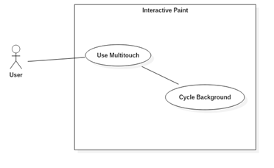

**Sequence Diagram**

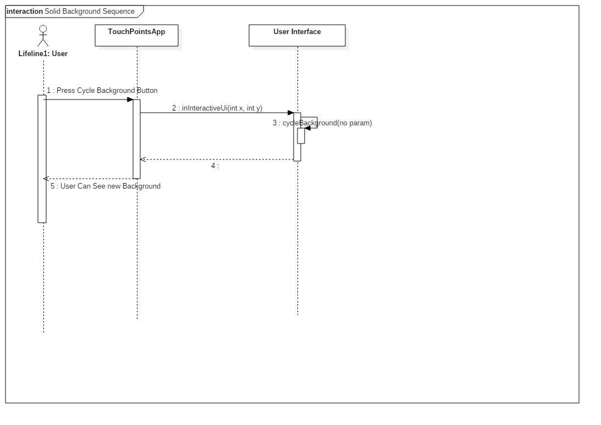

**Class Diagram**

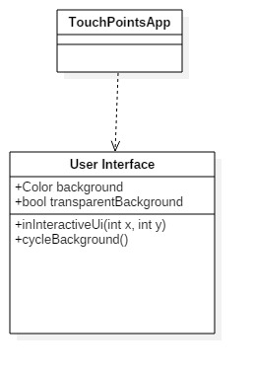

**Unit Test**

Sunny Day:

Test Case: Cycle through Background

Test Purpose:

Ensure that the user can cycle through backgrounds.

Test Setup:

1. Ensure multitouch is on.
2. Press the ‘11th’ button from the left of the buttons at the top left. (See User guide for a visual representation)
3. Continue to press the button until the background is white.

Test Output:

The user pressed the button the first time. The background became a checkerboard.

The user successfully pressed the button until the background became white again (indicating one full cycle occurred).

Expected Output:

The first button press should show a checkerboard background

Subsequent presses should change through a series of colors including Aqua, Blue, and Purple. Eventually looping back to white.

Rainy Day Tests:

Test Case: Save Transparent Background Image

Test Purpose:

Ensure the saving of images with a checkerboard background saves as an ‘alpha 0’ photo and not a checkerboard background photo.

Test Setup:

1. Change background color once.
2. Change to circle drawing
3. Enable filled shapes
4. Draw a circle
5. Press ‘n’ on the keyboard to save an image.
6. Open the image in sketchbook.
7. Attempt to change the background color.

Test Output:

After opening the file in sketchbook the user successfully could alter the background color.

Expected Output:

The background should change in sketchbook.

Test Case: Save Solid Background Image

Test Purpose:

Ensure the saving of images with a solid background saves as an ‘alpha 1’ Image which keeps the background color.

Test Setup:

1. Change background color twice.
2. Change to circle drawing
3. Enable filled shapes
4. Draw a circle
5. Press ‘n’ on the keyboard to save an image.
6. Open the image in sketchbook.
7. Attempt to change the background color.

Test Output:

After opening the file in sketchbook the user could not change the background color

Expected Output:

The background should not change in sketchbook.

**Integration Test**

Currently saving with a ‘transparent’ (Checkerboard background) saves a background with alpha color of 0. While saving with a different color background will properly save that background with an alpha of 1.

All devices still function properly. We can still draw with the leap motion, multitouch, as well as do UI functionality with the eyeX with the implementing of ‘solid’ and ‘transparent’ background cycling.

Now integrated with the ‘Settings’ Menu.

**User Guide**

With the multitouch on open the ‘Settings’ menu indicated by the green arrow.

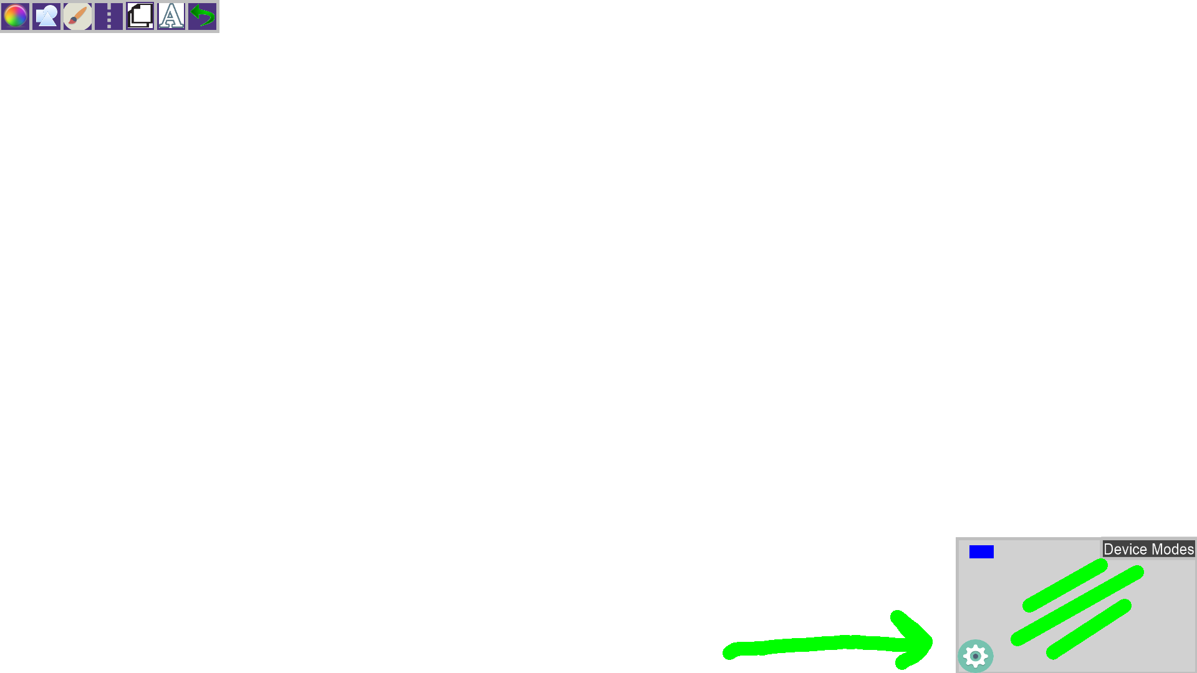

Now Simply press the ‘Cycle Background’ button to cycle through various background colors.

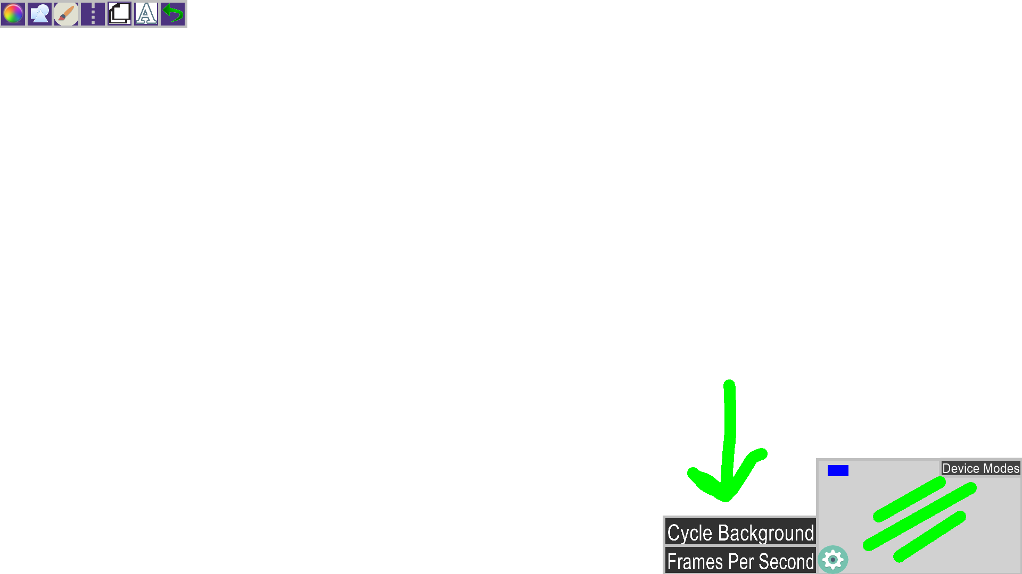

You can cycle colors, including transparent background shown below.

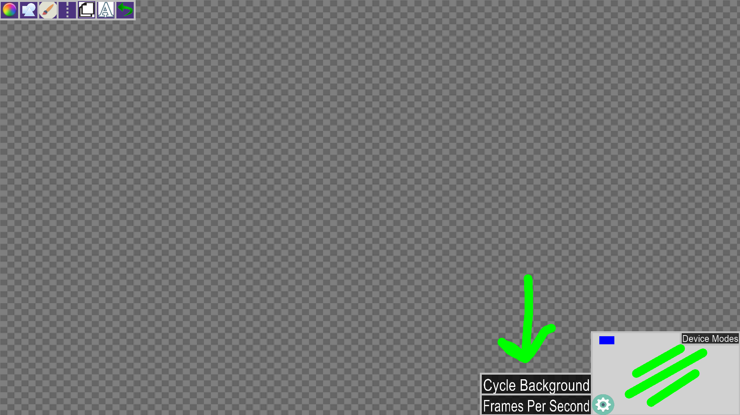

All other backgrounds will be saved as solid backgrounds.

**Glossary**

Transparent Background – A background color with an ‘Alpha’ of 0, indicating that it does not have a color defined. It makes it very easy to change the background color in programs such as photoshop or sketchbook. Indicated by a ‘checkerboard’ looking background.

Solid Background – A background, that when saved, will preserve the background color in a PNG. So having a ‘blue’ background will make the background of the image blue as opposed to an ‘empty pixel’